Context
After finishing your degree, you have obtained a position in the production planning department of Pedalworks PLC, a renowned manufacturer of bicycles in Belgium.
Your department often has trouble with other parts of the company as production is not adapted to meet demand. In some periods, hardly any customer orders are received, and the storage staff complain that too much warehouse space is being filled. In other periods, the sales department complains that many orders cannot be met because stock on hand has been exhausted and set up and production for a new batch takes too long.
Your boss has now given you the task of analyzing the reasons for these problems and suggesting potential solutions. You soon notice that one of the main reasons is that there is no correct demand planning and forecasting system.
You now believe that the implementation of strong forecasting methods and the creation of a strong production plan based on these figures would deliver much better results. However, first you would like to obtain an overview of the various forecasting methods and the possibilities for their implementation. As your boss has a rather negative attitude to such methods, you then plan to convince him of your idea using an example calculation.

Exercise 1: The different forecasting methods
Give examples of each of the following methods:

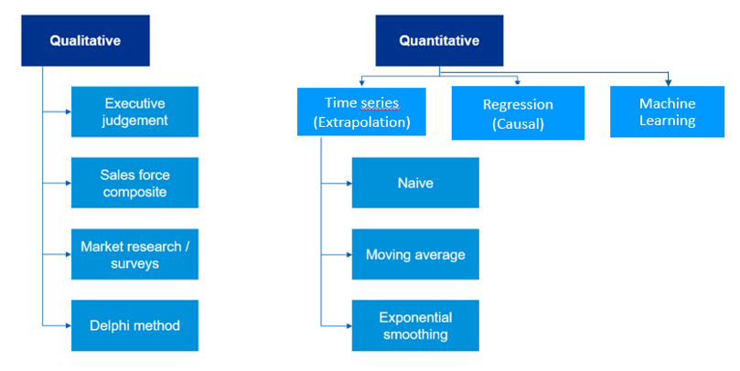

Exercise 2: Which methods are best suitable for each phase of a product lifecycle?
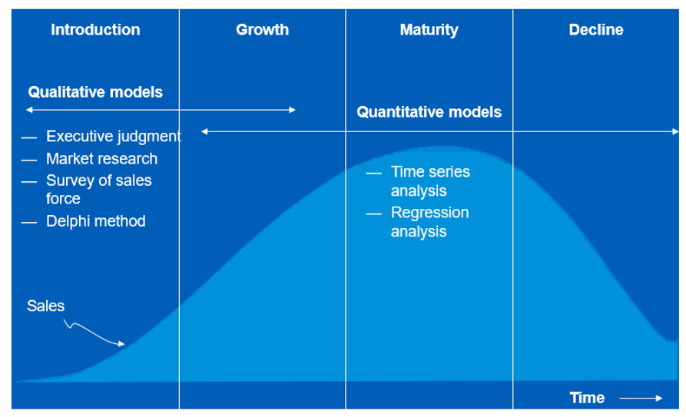

Exercise 3: The estimation of forecast error
It can generally be said of any forecast that it will most likely be wrong. Discrepancies between the forecast and the actual values are very difficult to avoid. However, there are differing reasons for these discrepancies.
It may be possible to take corrective measures (e.g. when a structural change in demand took place or if false data were used), but in other cases we must accept these discrepancies (statistical discrepancies).
How can statistical discrepancies be determined?
- Forecast bias (or forecast error) = Actual sales – Forecast
This measurement gives an indication of over or under forecasting.
- Forecast accuracy = measure of the accuracy of the forecast
Lower forecast errors (positive or negative) mean more accurate forecasts.
- Mean Absolute Deviation (MAD) = Average of the absolute forecast bias over the last n time buckets.

Exercise 4: What kind of external factors do influence the demand for your product and should be included in the forecast? Name 5 of them.
- Fuel prices: the tendency to switch from personal cars to bicycles will increase if fuel prices increase.
- The bicycle network: the better the network, the more bicycles will be used.
- New competitor: if a new competitor arrives on the market, we are at risk of losing some customers.
- Decrease of Belgian population's purchasing power.
- Weather: if it rains much more one year, it’s probable that bicycle usage will decrease that year.

Exercise 5: Forecasting
You are now ready to make the forecast. You therefore obtain this year and last year’s sales figures. Go in the excel “ILP - Module 4 - Demand planning & forecasting - Business case” and:
- Forecast the sales for December 2025 using 6 months moving average (cell in green the Excel).
- Do the forecast performance analysis for January to November, using 5 months moving average for the MAD (cells in orange in the Excel).
- Make a graph to visualize what is/are the biggest sales period(s) and what is/are the lowest sales period(s).
- Can you interpret why one can see those peaks and drops at these specific periods?
- Sales reach their peak during the spring. This is because weather is better and so people start to use bicycles again and so to buy new ones.
- In July and August, Sales are lower because people are on holidays and do use the bicycles bought in Spring.
- In September and October, there is another small peak because some people do replace their bicycles after having used them the whole spring and summer.
- In November, there is a drop as people do not buy bicycles anymore because of the weather and the days getting shorter.
- The peak in December is caused by Christmas when some people do buy bicycles as gifts.
Exercise 6: Forecasting adjustment
We are now in 2026, and February’s Sales have been much higher than usual. Can you read the small text below and explain why?
Some good news in Belgium in the last few weeks have brought a wave of positivity across the country. The job market has shown encouraging signs, with small and medium-sized businesses reporting steady growth and new hiring initiatives. Meanwhile, cultural life is flourishing again, with local festivals and community events attracting large crowds and supporting local artists. One can also note that the cycle paths linking Brussels to Walloon Brabant and Flemish Brabant are finally finished. Finally, in addition to this major step forward for sustainable mobility, several cities have announced new investments in renewable energy projects, including expanded solar panel installations on public buildings Altogether, these developments highlight a period of progress and renewed confidence throughout Belgium.
This is because the cycle paths linking Brussels to Walloon Brabant and Flemish Brabant have now been finished Some people that used to come by car from these provinces can now come by bicycles.
Do you think this increase is structural or not?
Yes, the increase is structural as this is due to a long-term improvement of the bicycle network. This means that this external factor will need to be considered to adjust the forecasts upwards.

